**STEP 1:**

**Question 1:**

First, when gridworld.py -h is executed to understand the different options, the following output is obtained:

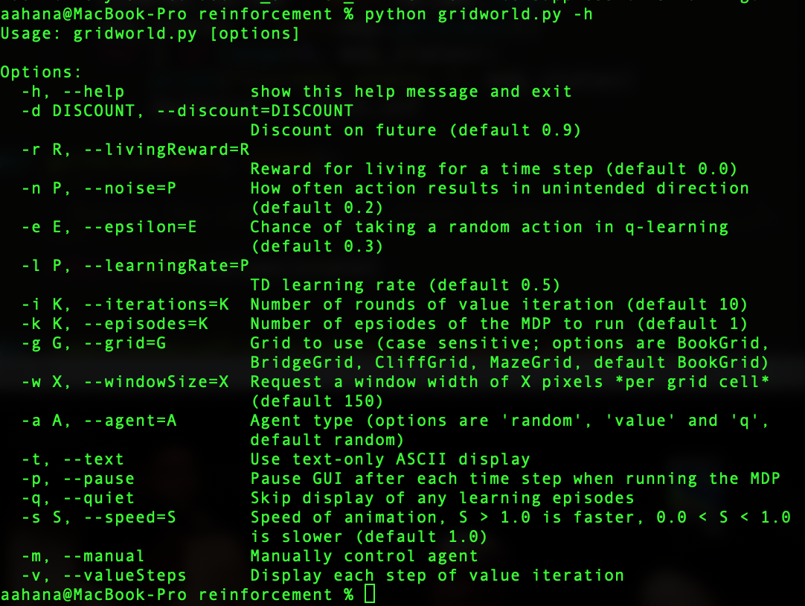

Then, valueIterationAgents.py is edited to perform value iteration. I start by pulling all the MDP states and printing them. I got an error for taking a range on a list.

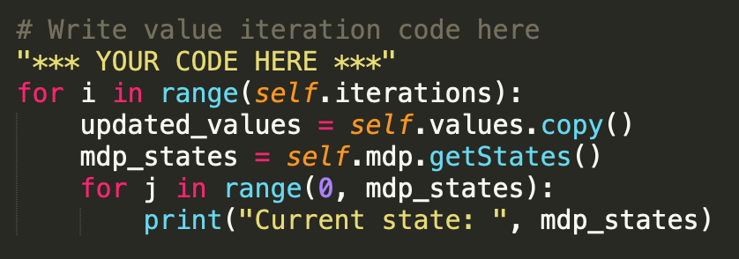



Hence, the range function is taken away and all the MDP states are printed and all the MDP states are printed out.

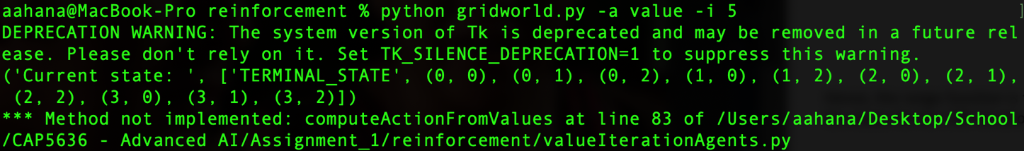

I wanted the max_value of a state to be initialized to negative infinity. I tried to use the math library for it. However, I ran into errors. I fixed it by using float(‘-inf’). This seemed to work.

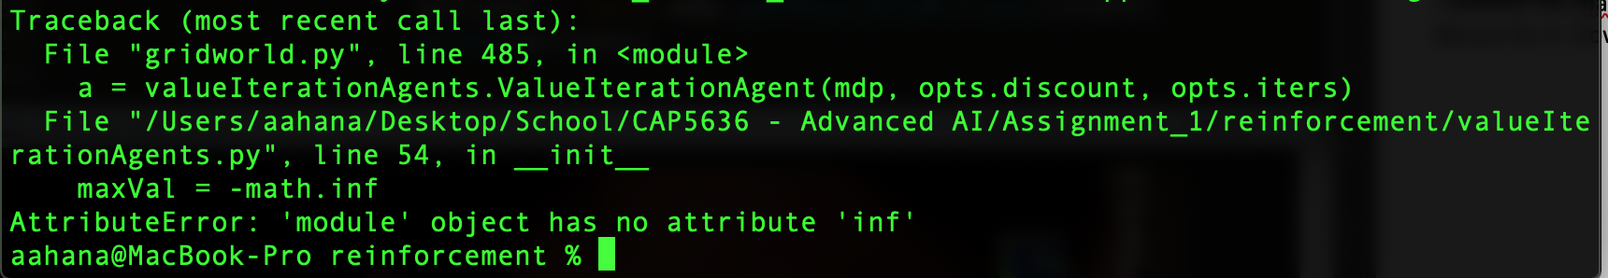

Next, I wanted to print all the actions for a given state. My code at this stage looks as follows:

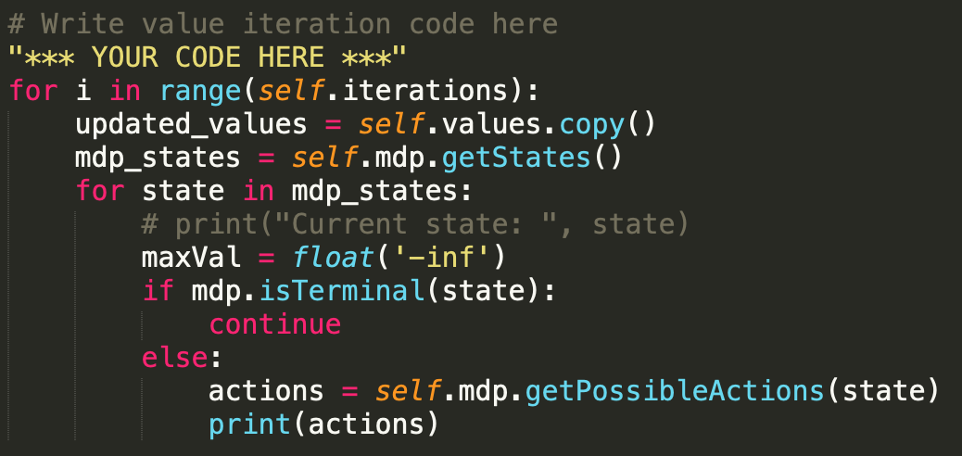

Output obtained for one iteration is as follows:

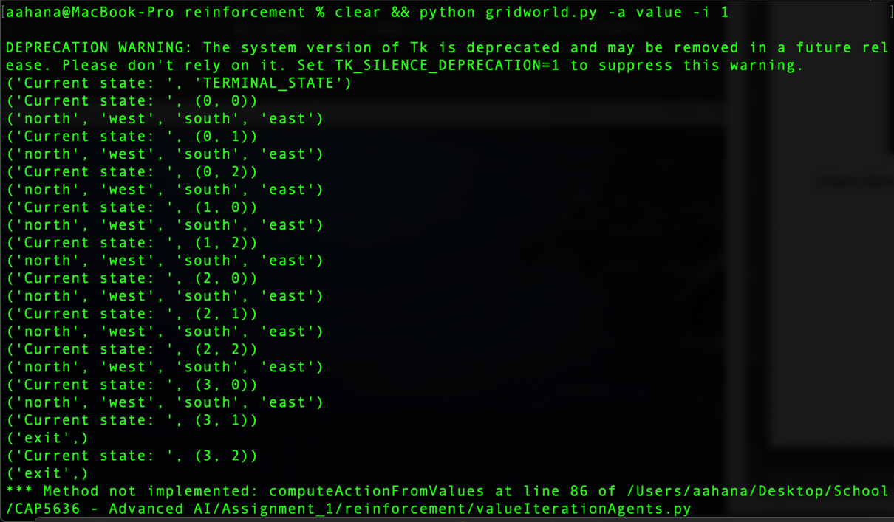

Once all possible actions for a state are found out, the next step is the calculate Q values for all these actions available from a state. For this, I just implemented the Q-value formula in the function computeQValuefromValues and passed the present state and action as parameters to it. To get the Q-value, I first need transition functions (probabilities) and the next states. My code snippet and the corresponding output looks as follows:

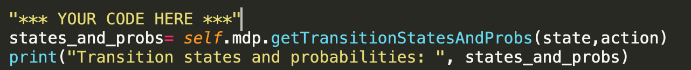

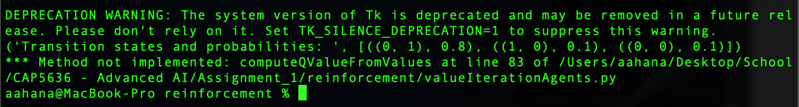

Since, states_and_probs is a list with tuple values within it, the transition state and the transition probabilities for each state and action can be printed out.

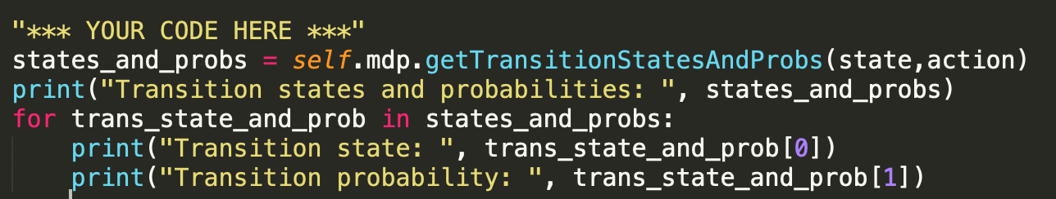

Output looks as follows:

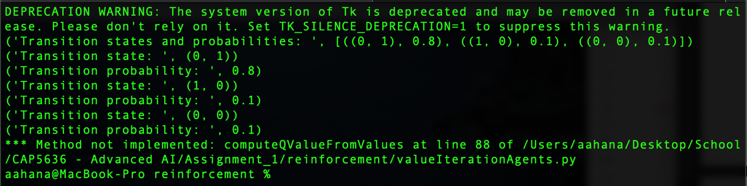

Next step is to calculate the reward for taking an action from a state and moving to the next state. This can be calculated using the function self.mdp.getReward(). The output after 1 iteration is shown below.

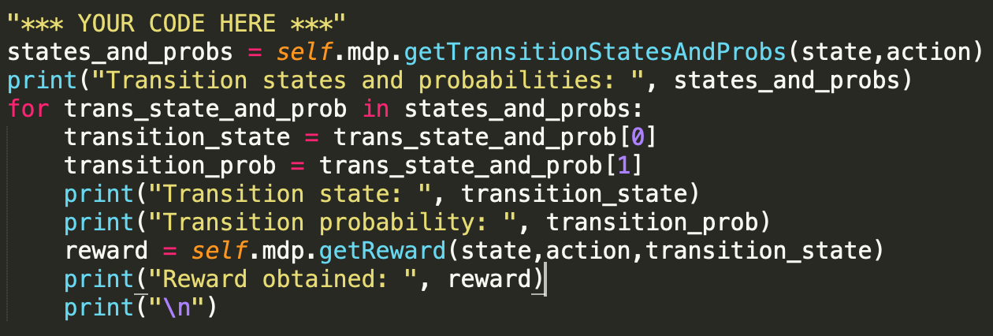

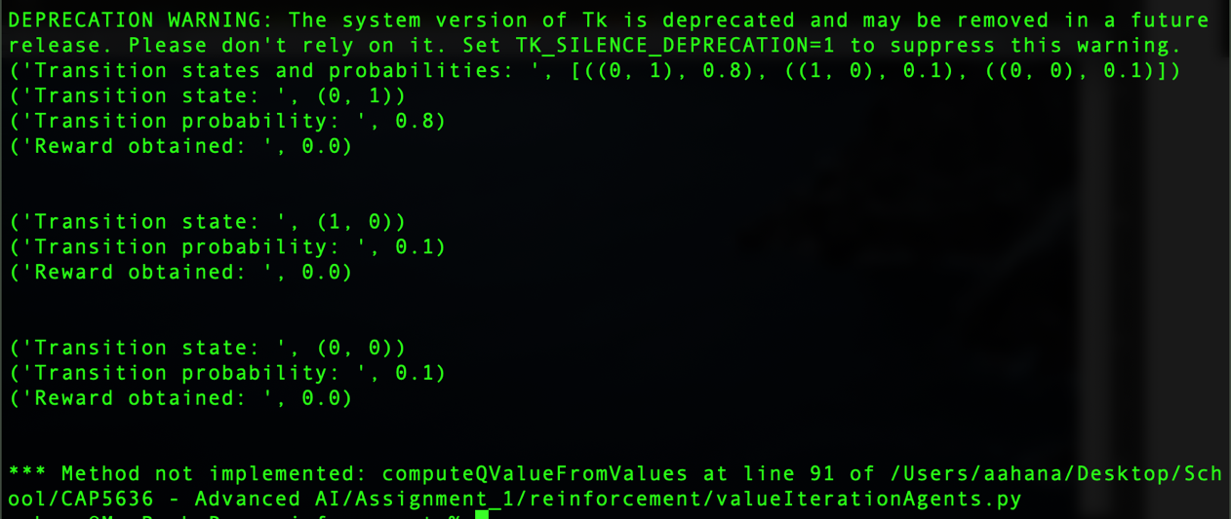

Using the formula for Q-Value: Q-value = summation over s’{T(s,a,s’) [R(s,a,s’) + discount * V(s’)]}. However, this gave me an error for not initializing Q-value = 0 in the beginning. Once, done, the output for Q-value given a state and action was calculated.

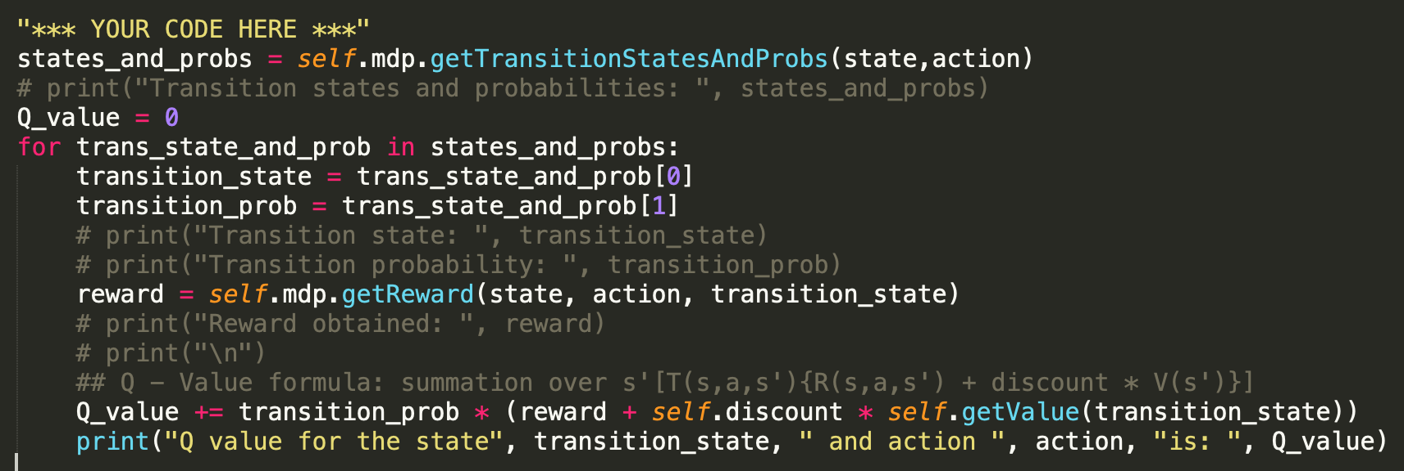

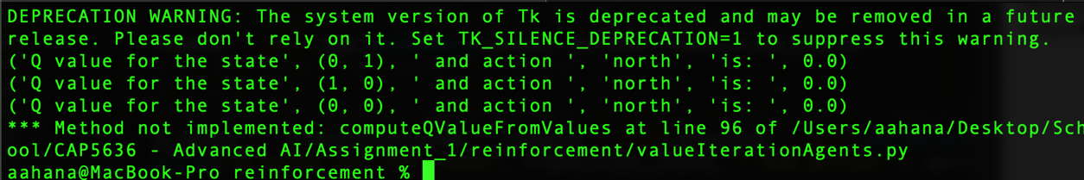

Once Q-values are calculated, we find the max Q-value. However, the output did not look correct.

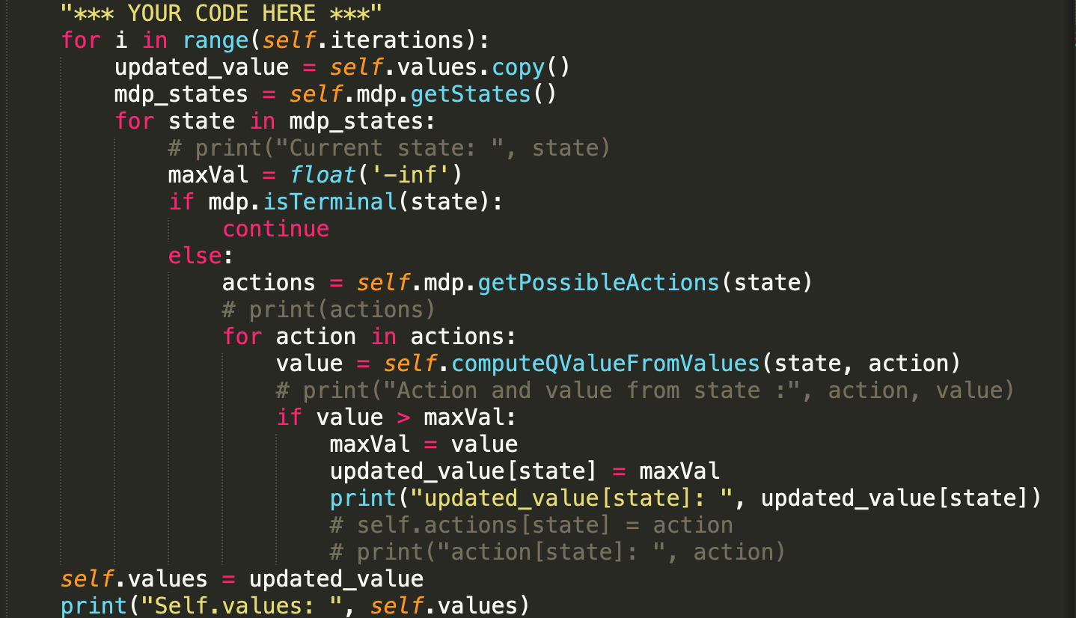



I realized that the indentation was wrong and that I had to update the value of the state only after checking all possible actions from that state. Also, the state values have to be updated at the end of every iteration. Once these errors were fixed, the code and the outputs are as follows:

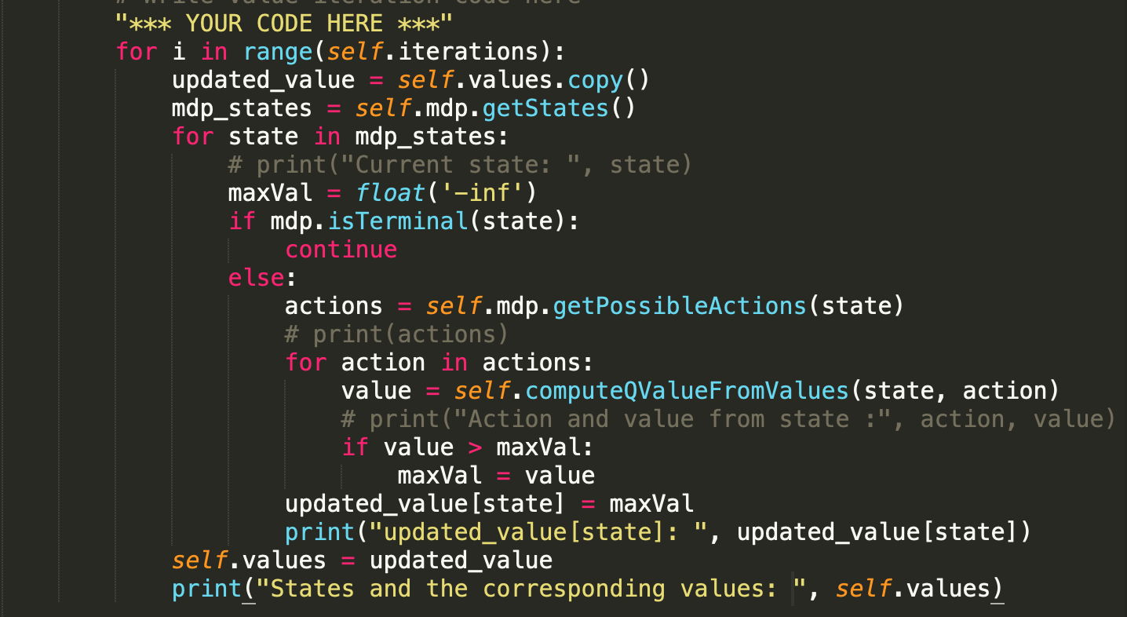



As seen above, the values obtained match the values that need to be obtained by the 5th iteration.

Next, I need to be able to generate the gridworld to show the values that I have generated. So, I need to work on the last function computeActionFromValues(). For this, I do the same process that I did for finding the largest value of a state. However, this time, I want to record the action that gives the largest value for a state.

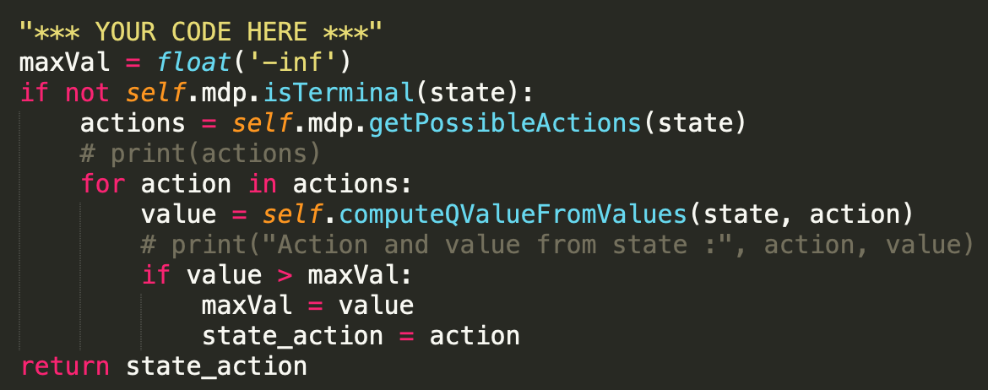

I got an error for not defining ‘state_action’, hence I had to state_action to a default value as “north”.

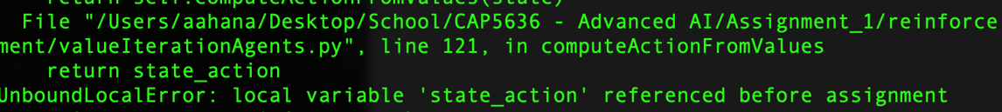

At the end of this, the output is obtained:

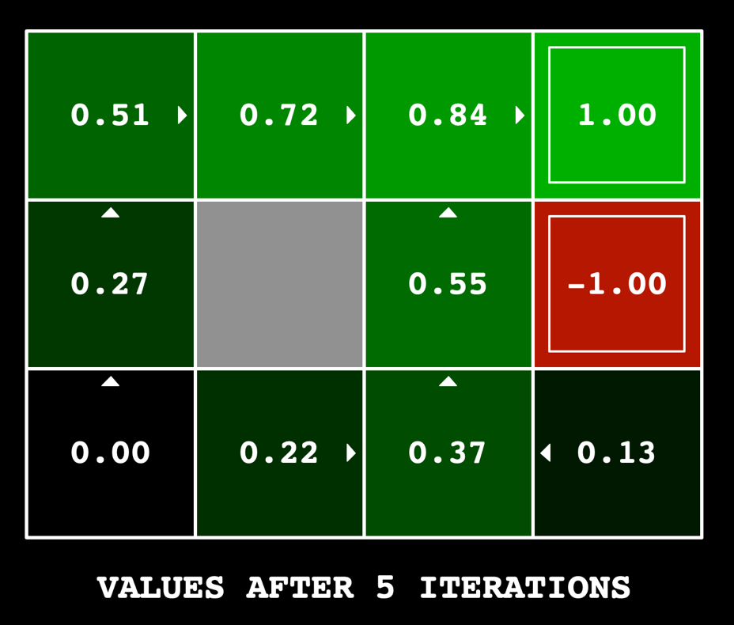

**Question 2:**

The purpose of this question is to modify either the discount or the noise to be able to send the agent across the bring to the +10 reward. Currently, with a noise of 0.1 and discount of 0.9, the output looks as follows:

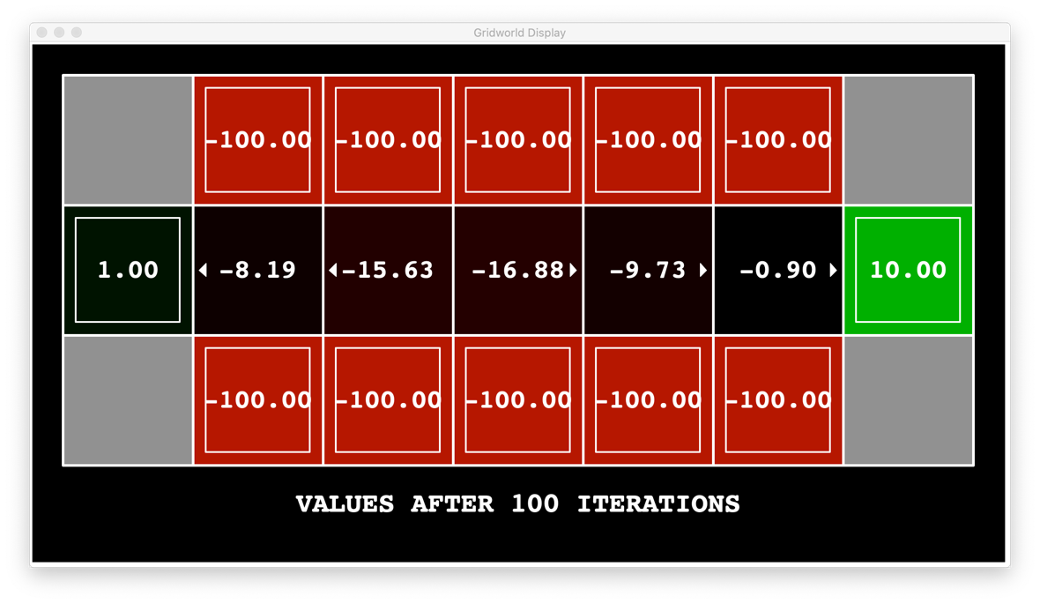

I changed the discount values a couple times to see if I could get the agent across the bridge. Some of the outputs look as follows:

When noise is 0.1 and discount is 0.8 and discount = 0.6 is shown below:

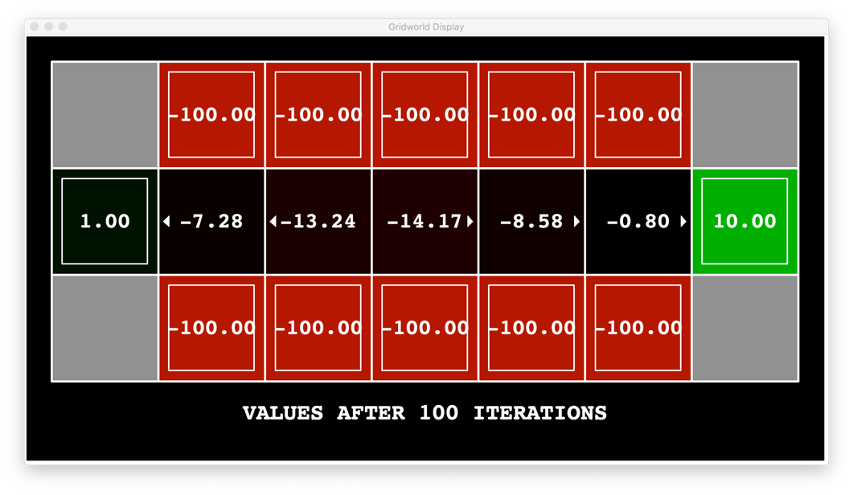

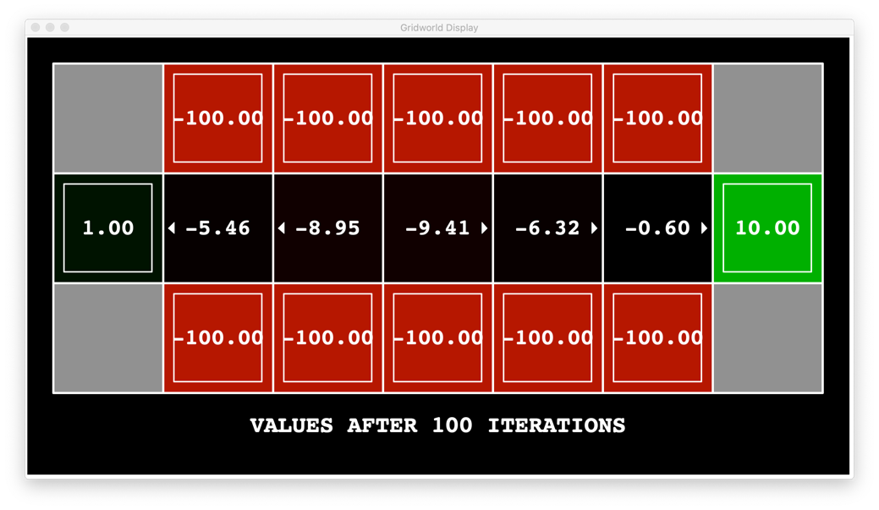

Then, noise = 0.1 and I reduced discount even further to 0.5. The outputs look as below:

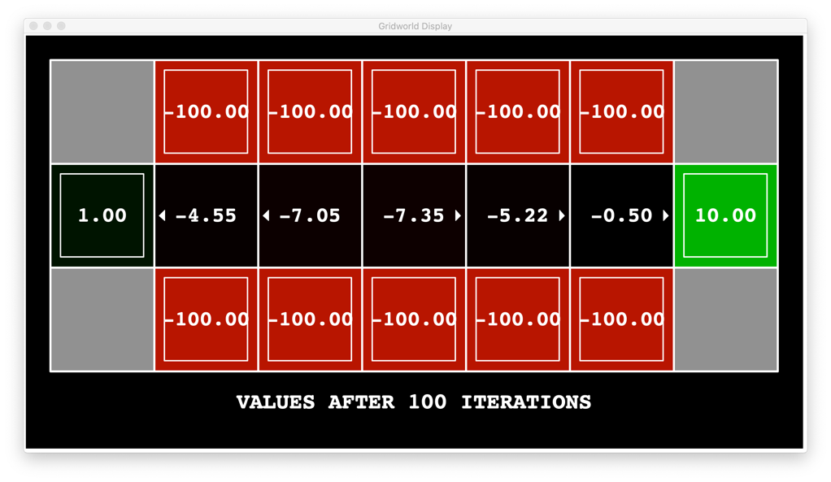

Once I noticed that changing discount is not allowing the agent to get across the bridge, I decided to change the noise. We want the noise to be as low as possible to have the agent get across the bridge. I started reducing noise by small numbers. Output when discount = 0.9 and noise is 0.07 and noise = 0.05 is as follows:

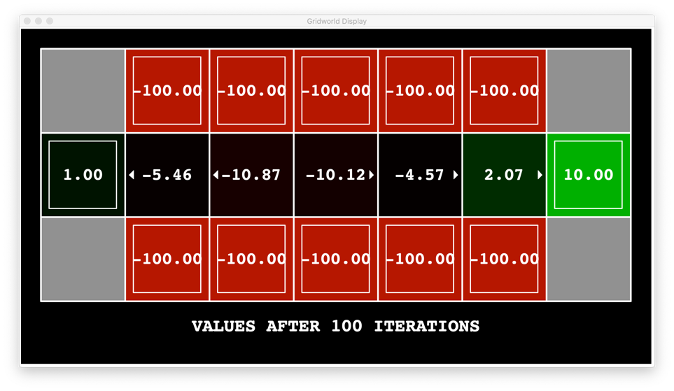

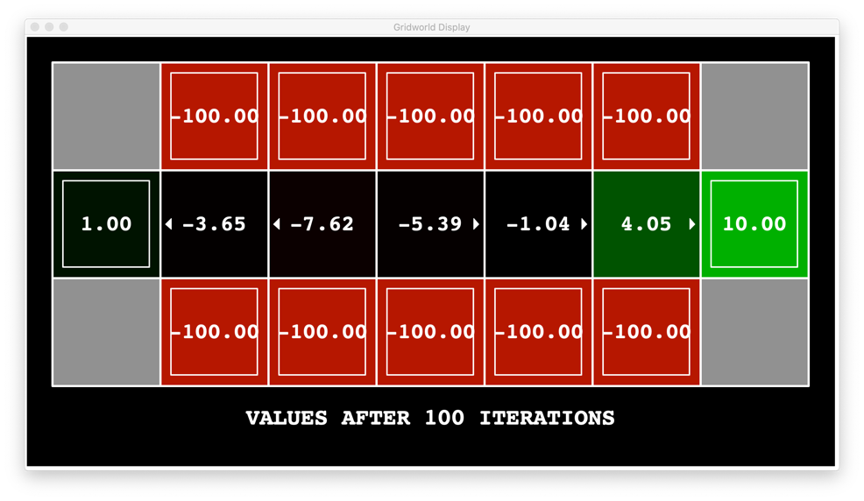

Output when discount = 0.9 and noise 0.01 is as shown below:

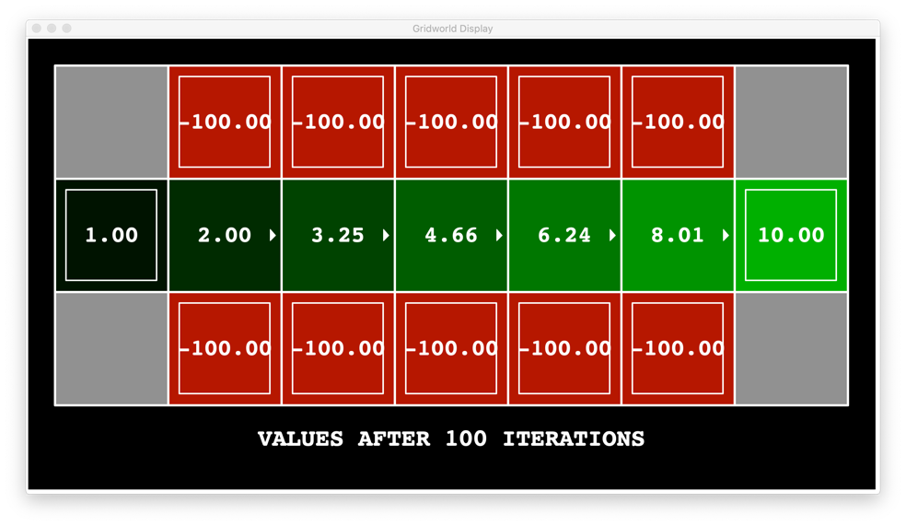

Ideally, we could just set noise to 0.0 and discount to 0.9 and have the agent cross the bridge. The output would look as shown below:

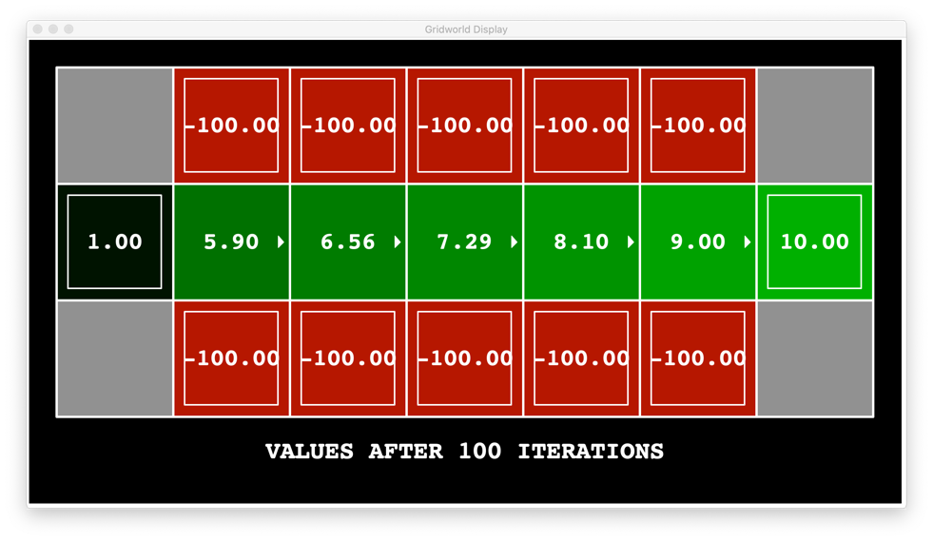

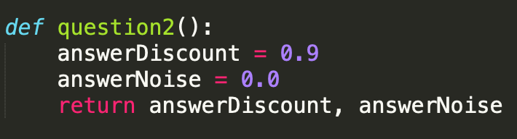

The corresponding Q – values for noise = 0.0 and discount = 0.9 is as shown below:

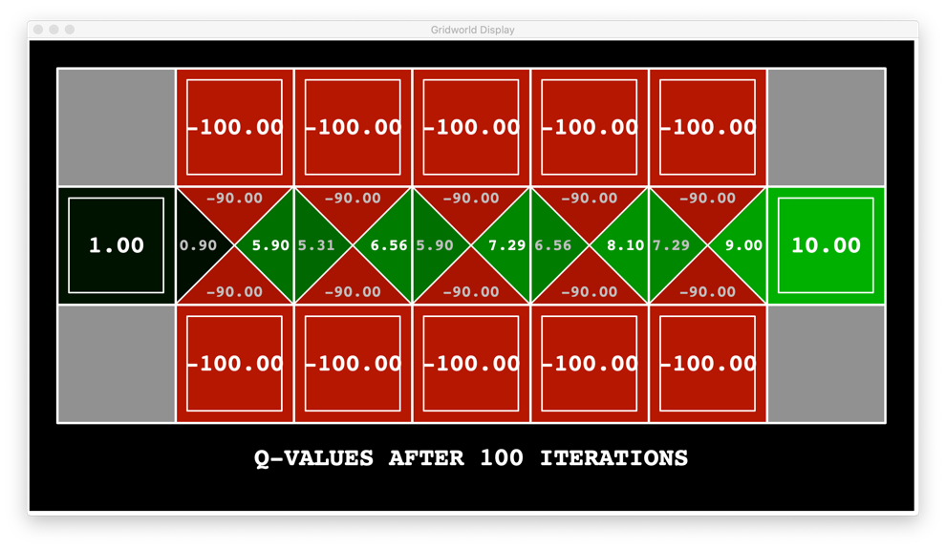

For all values of noise below 0.016, the agent moves across the bridge if it were to follow the optimal policy indicated by the arrow marks. The output when **discount = 0.9 and noise = 0.016** is as shown below:

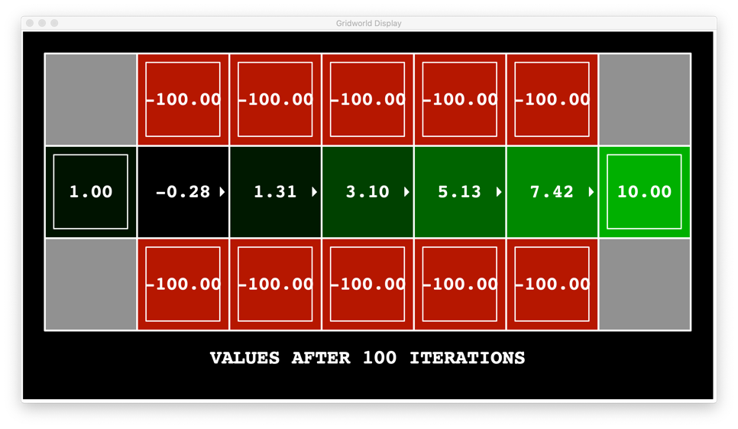

**Question 3:**

For this question, I randomly started giving values for discount, noise and living reward. Some of the different combination of values for the parameters that I tried, and the corresponding outputs are below.

Try 1: discount = 0.9, noise = 0.0 and living reward = 0.0

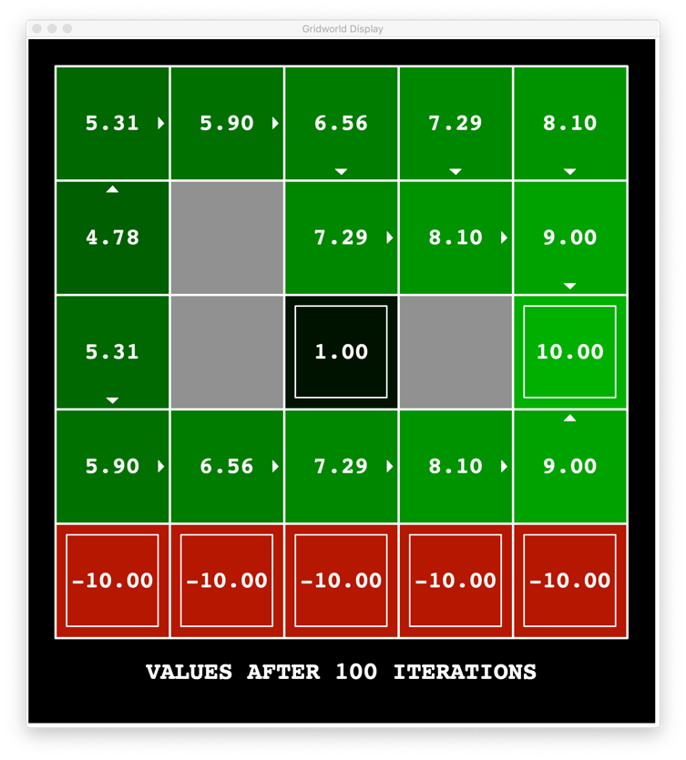

If I want the agent to take the shorter path along the firepits, then I want to make the living reward negative, in a way that the agent is motivated to take the shorter path.

Try 2: discount = 0.9, noise = 0.0 and living reward = -0.8

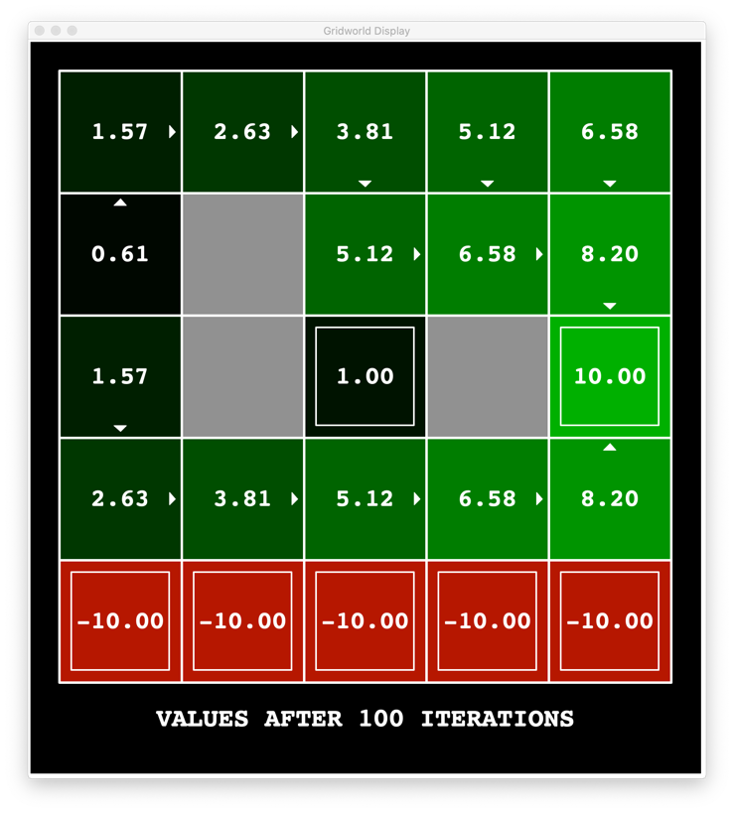

Clearly, I am on the right track, I just have to decrease the living reward even further.

Try 3: discount = 0.9, noise = 0.0 and living reward = -100

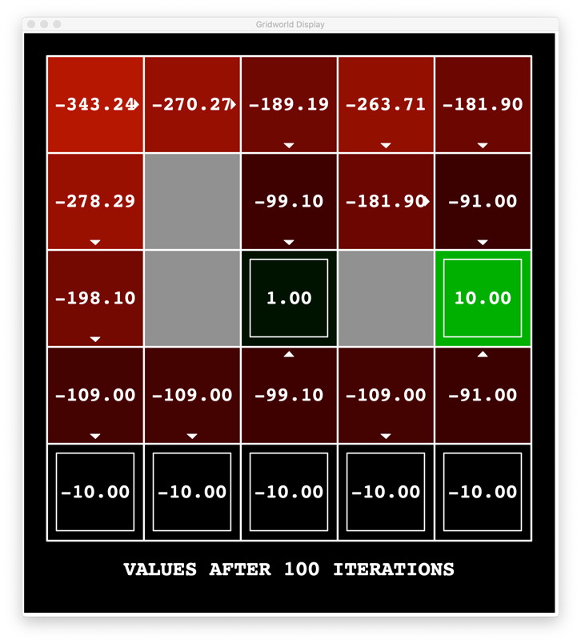

That was way too low of a living reward.

Try 4: discount = 0.9, noise = 0.0 and living reward = -2

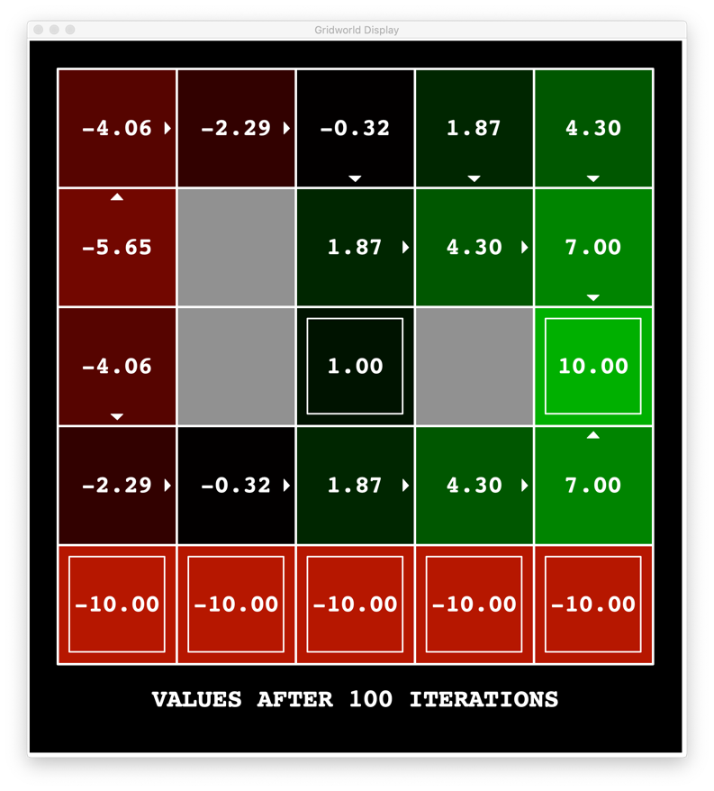

**Question 3a:**

Try 5: **discount = 0.9, noise = 0.0 and the living reward = -5**

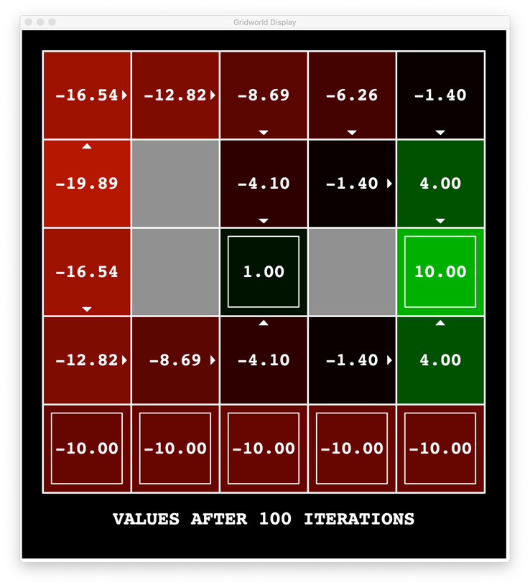

The living reward is still too low but the desired policy for question 3a is achieved. The agent moves along the firepits and takes the reward +1, when discount was set to 0.9, noise = 0.0 and living reward = -5.0. Similar output was obtained when living reward was set -4.0. The Q-values for this are shown below:

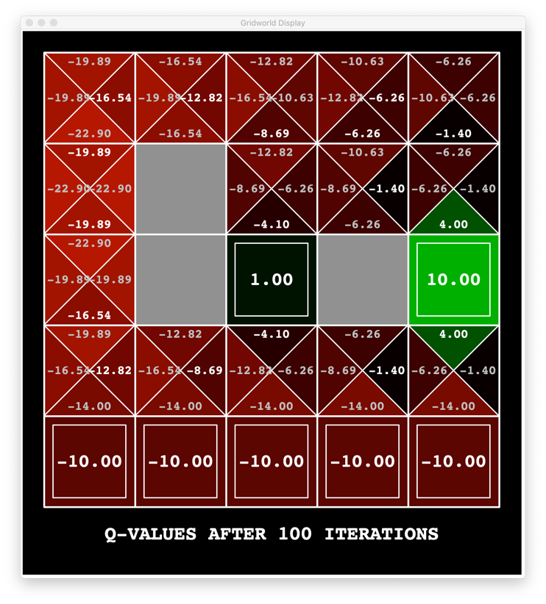

To find the policy that takes us away from the cliff, I set the living reward low as it doesn’t matter how many steps the agent takes to reach the final reward. Here are some tries that I made to achieve the desired policy.

Try 1: discount = 1.0, noise = 0.1 and living reward = 0.0

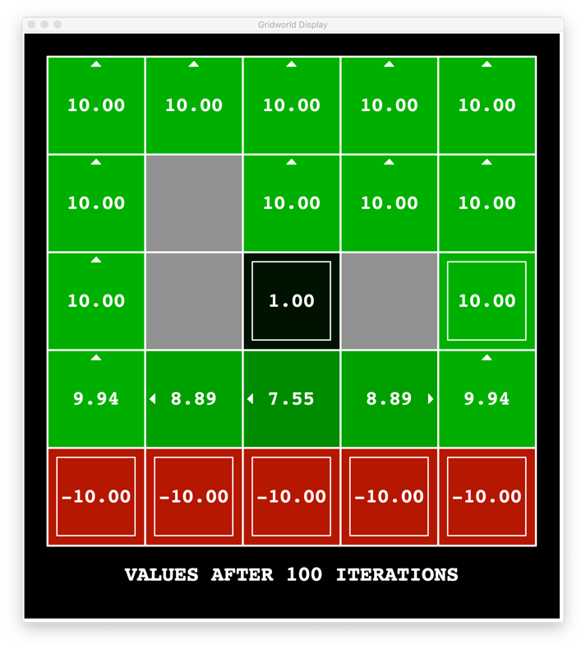

This kind of achieves the purpose by moving away from the fire pits and taking the longer path. However, it does not take the agent to reward = +1.

Try 2: discount = 0.1, noise = 0.5 and living reward = -1.5

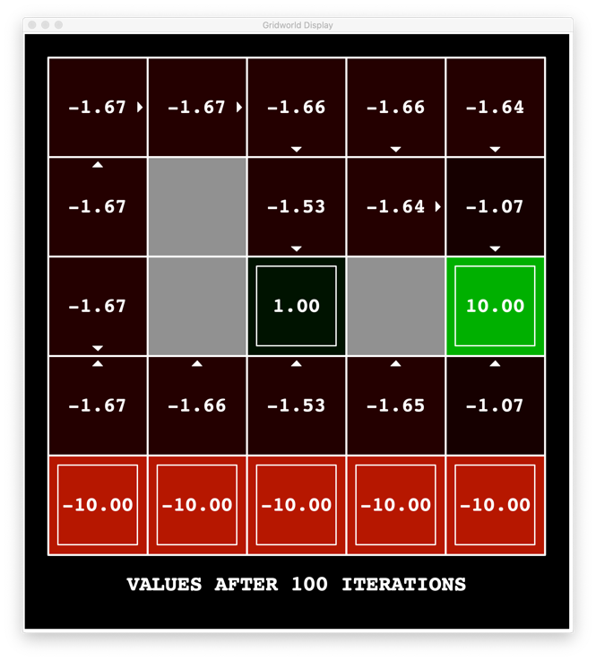

I then tried to reduce the noise and the living reward a bit and I ended up with the policy we were looking for.

**Question 3b:**

Try 3: **discount = 0.1, noise = 0.1 and living reward = -0.9**

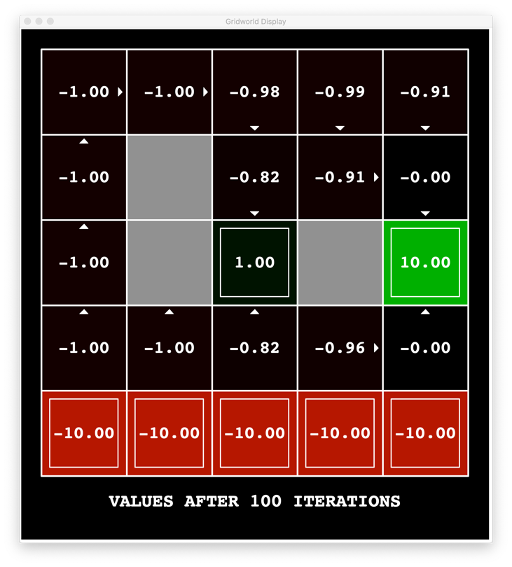

The corresponding Q-values are shown below:

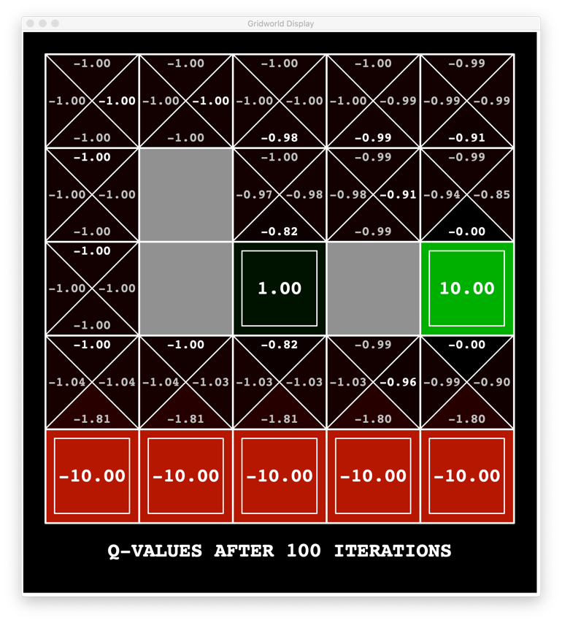

During one of my previous tries, I accidently found the values for discount, noise and reward that would have the agent to the reward +10 by moving along the firepits. I immediately made a note of the parameters.

**Question 3c:**

Try 1: **discount = 1.0, noise = 0.0, living reward = -0.4**

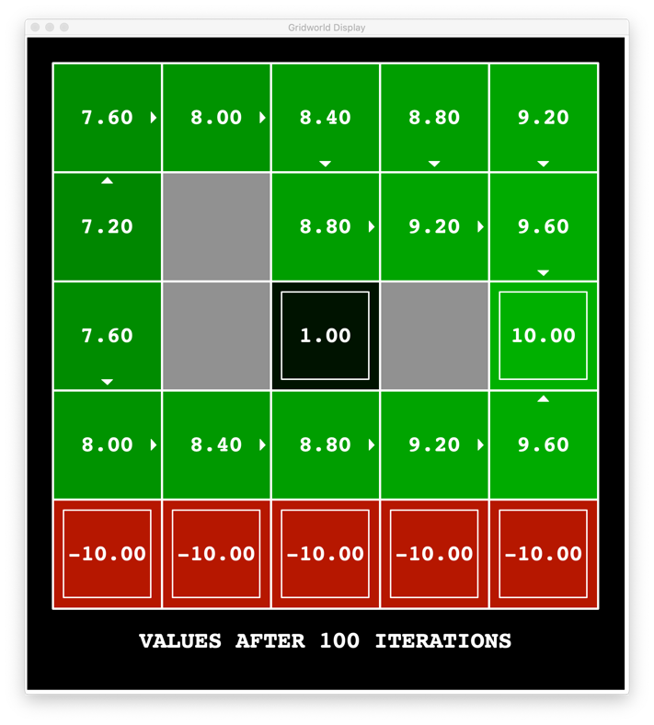

The corresponding Q-values are:

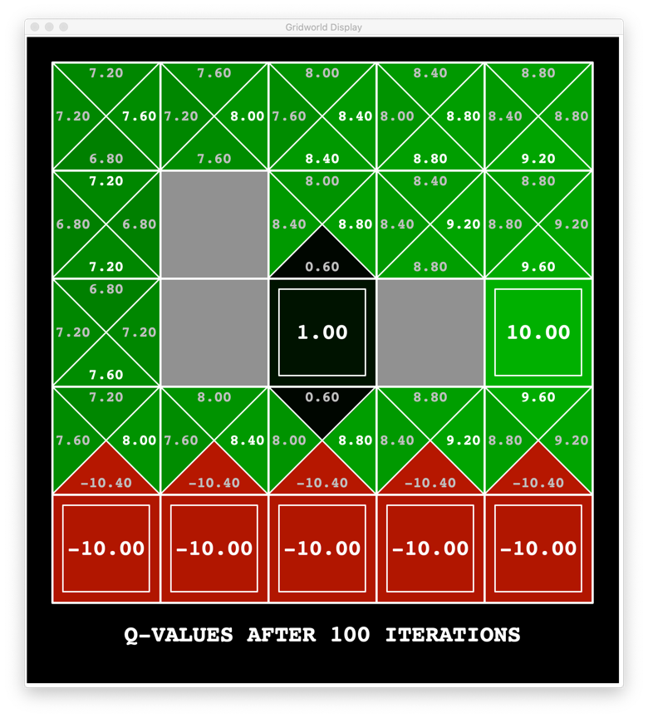

Next, to get to the furthest reward and to avoid the firepits to take the longer route, I decided to set a high positive living reward.

Try 1: discount = 0.9, noise = 0.0, living reward = 40

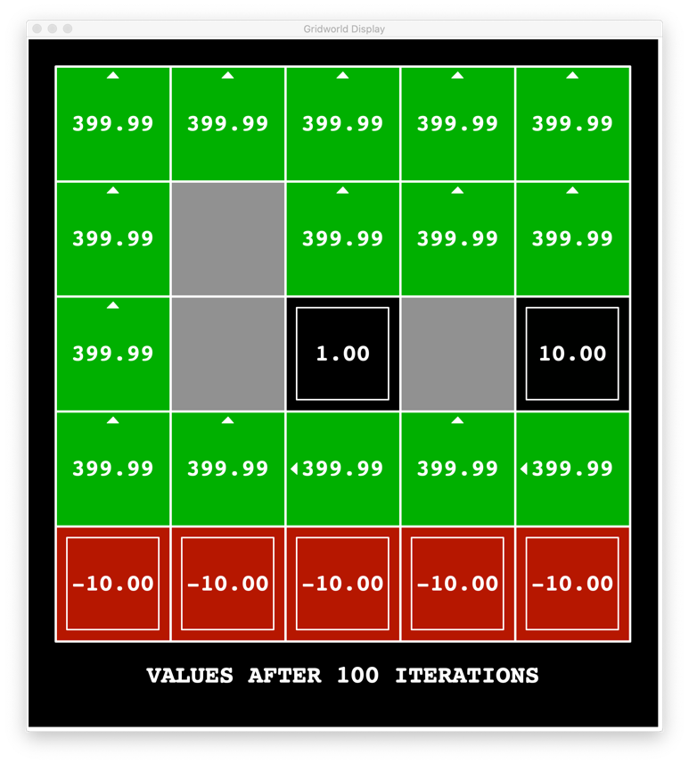

I figured I was in the right direction but just had a high living reward. Hence, I reduced the living reward down.

Try 2: discount = 0.9, noise = 0.0, living reward = 5

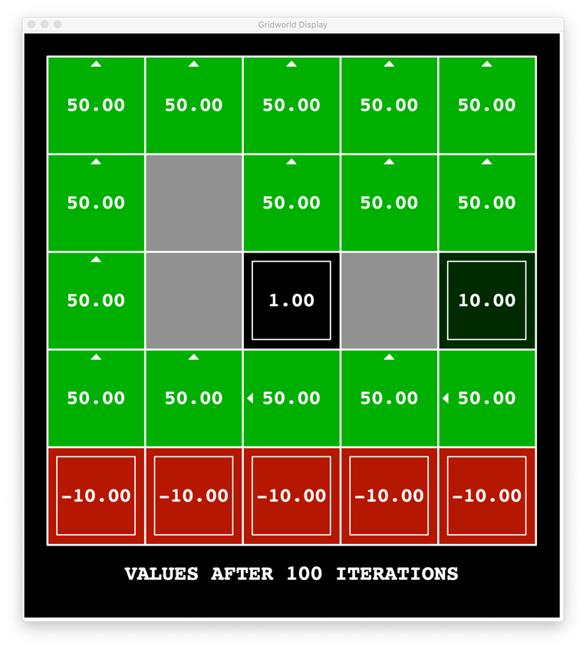

Try 3: discount = 0.5, noise = 0.0, living reward = 5

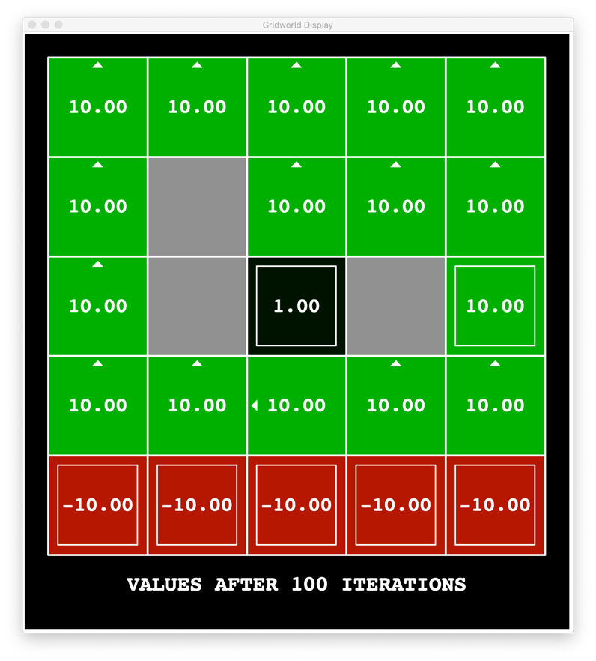

Next, I decided to change the discount and noise a bit to get the desired policy.

Try 4: discount = 0.1, noise = 0.0, living reward = 5

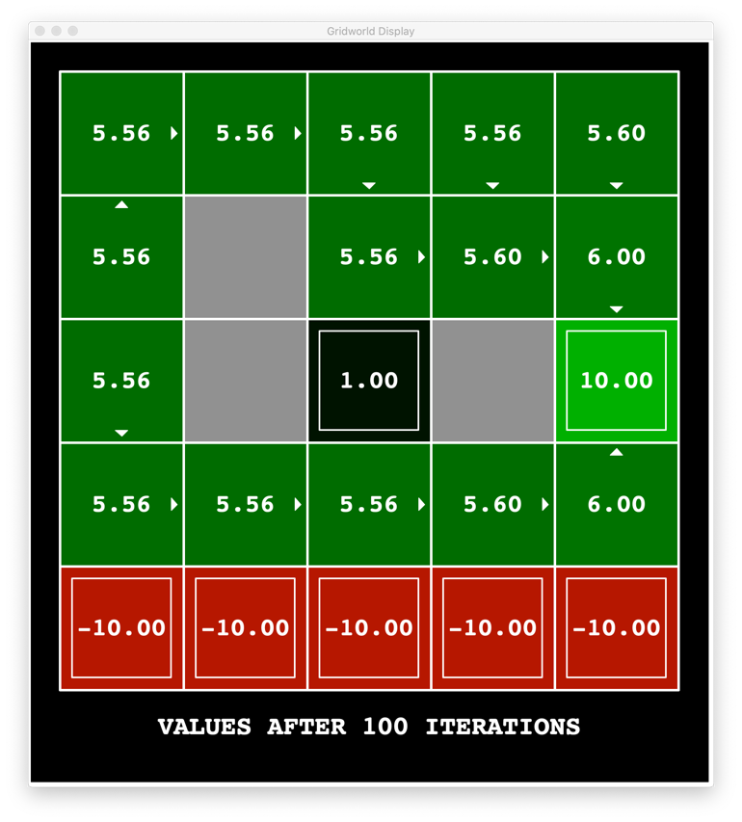

**Question 3d:**

Try 5: **discount = 0.1, noise = 0.1, living reward = 5.0**

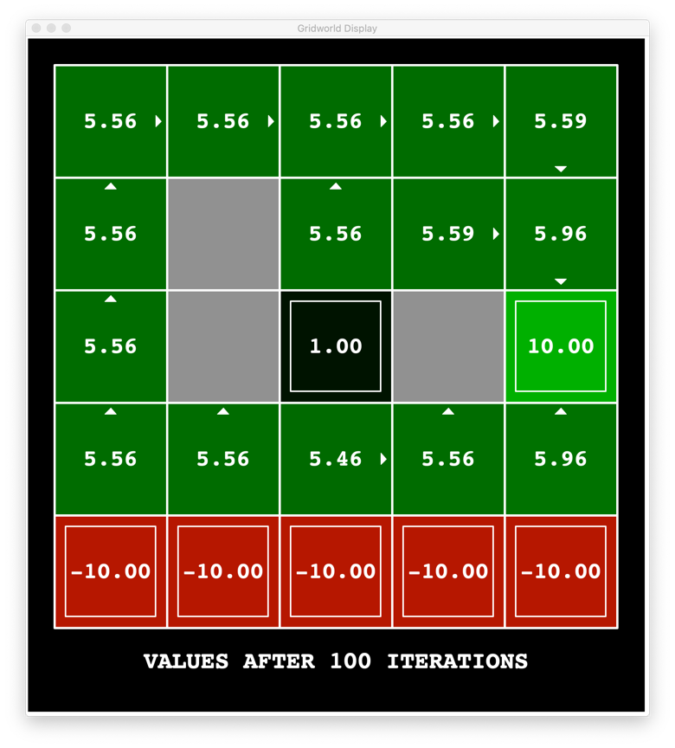

The corresponding Q-values for these parameters are as follows:

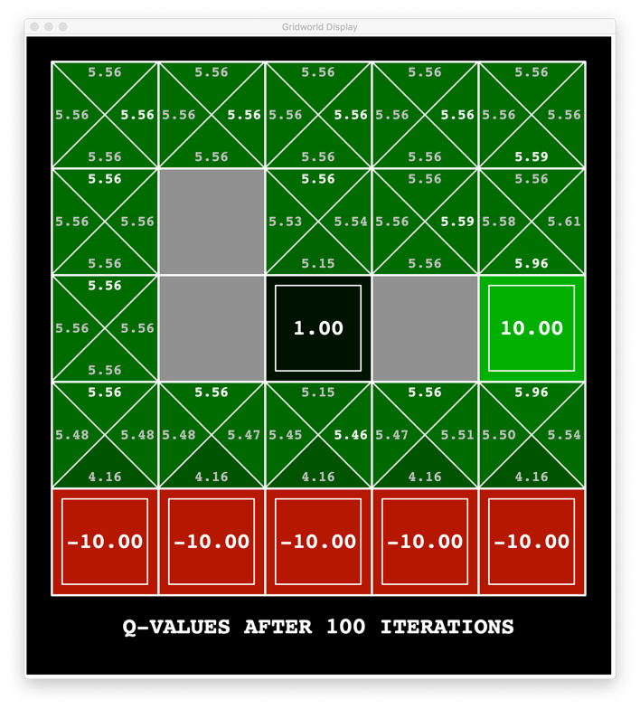

I was able to send the agent on an infinite loop by setting discount to 1.0, noise to 0.0 and living reward to 0.0. These parameters were found during one of the several combinations that I tried on the *discountgrid*. For these parameters, the agent does not get any reward.

Question 3e:

Try 1: **discount = 1.0, noise = 0.0 and living reward = 0.0**

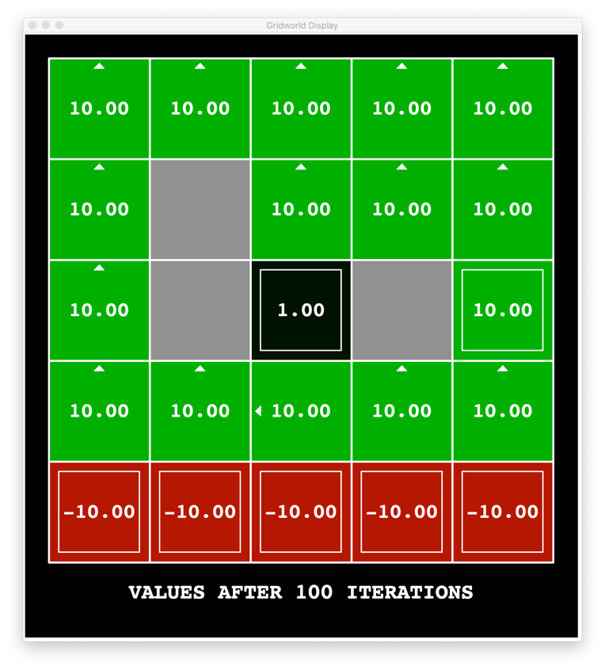

The corresponding Q-values for this grid is as follows:

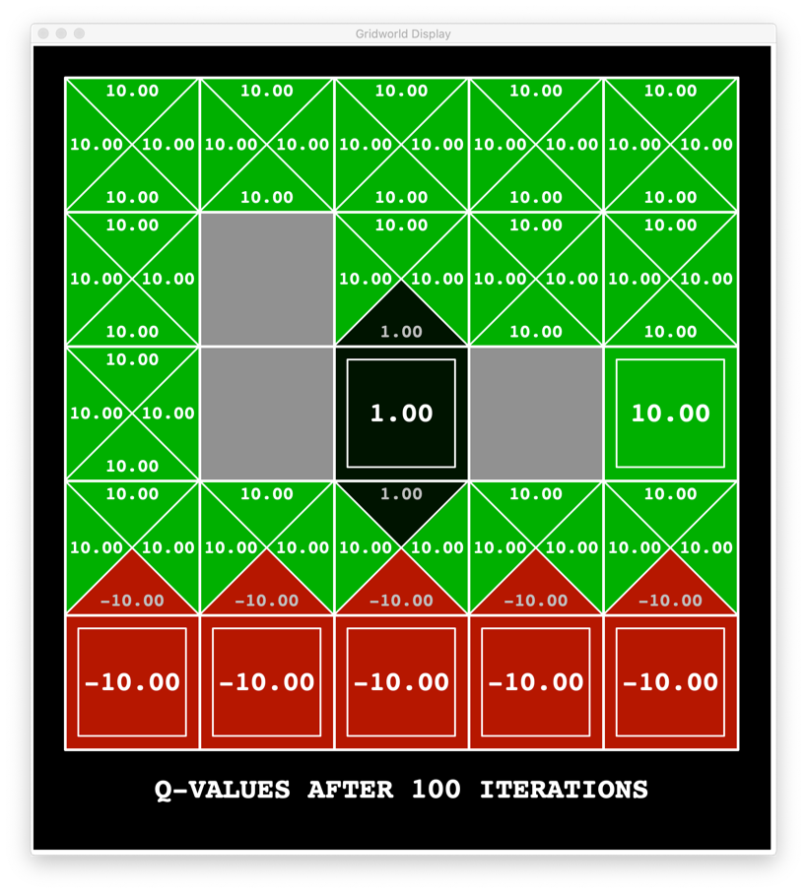

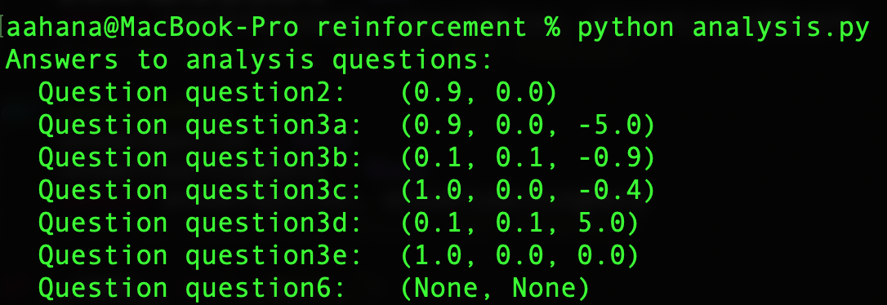

**Question 4:**

Initially, Q-values look as follows:

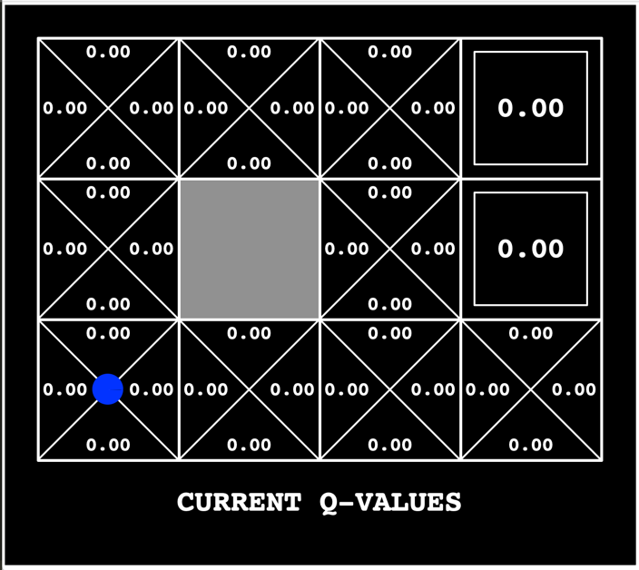

Similar to question 1, first I calculate the maximum value for every action in a given state.

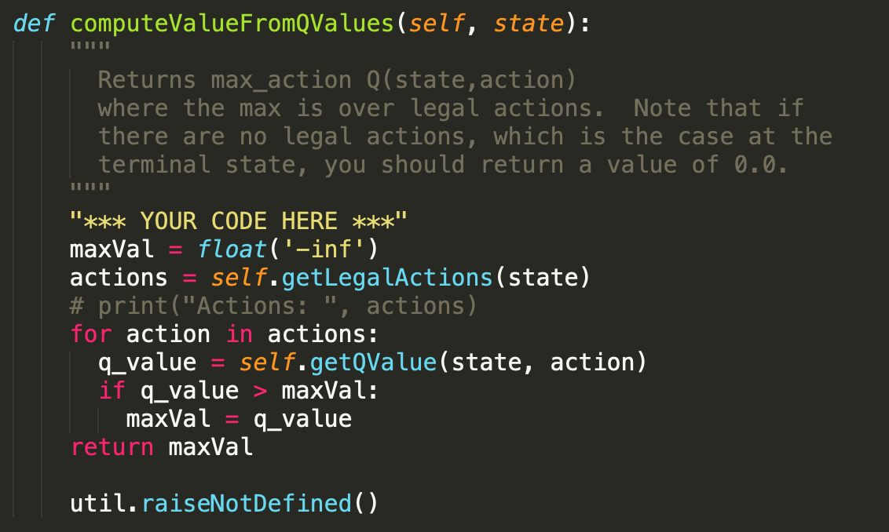

Similarly, I got the action that gives the maximum Q value.

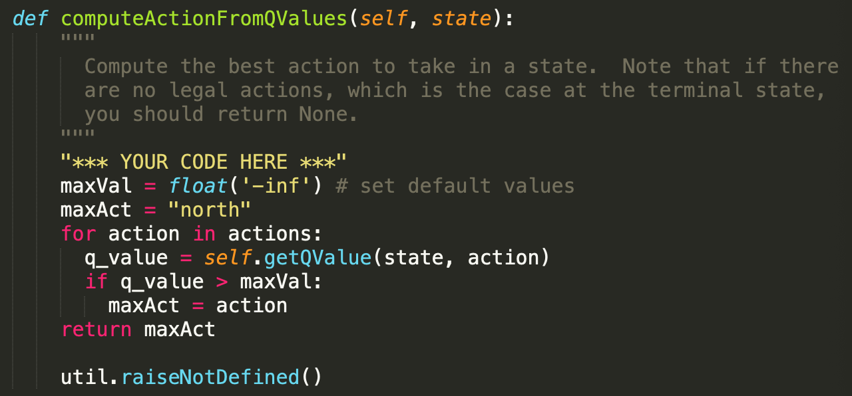

Next, we have to update the values of the Q-learner. For this, I used the formula:

**Q value = (1 - alpha)*current_Qvalue + alpha*[reward + discount*Qvalue(next_state)]**

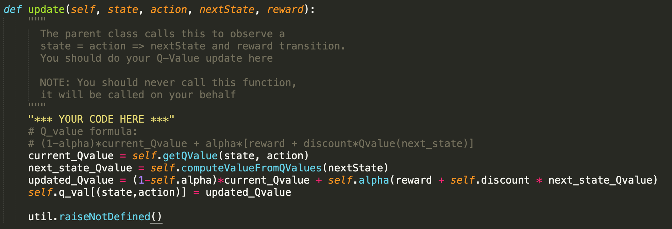

Next, to get random actions for a state, I used random.choice:

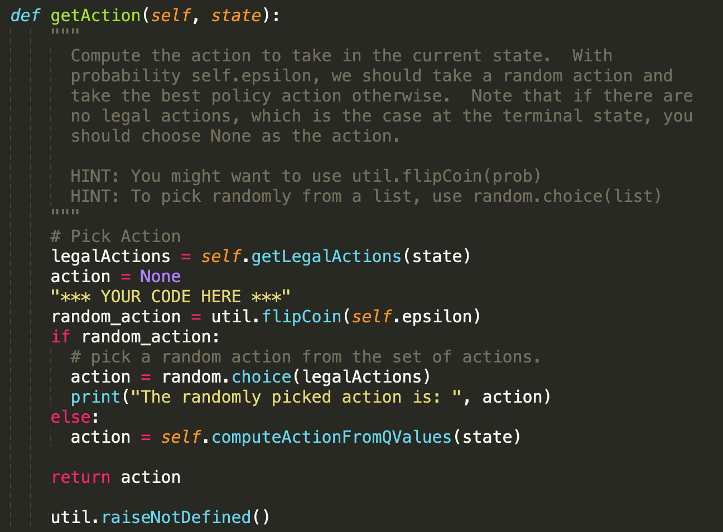

Once done, I initialize Q value and find Q values within getQValue function.

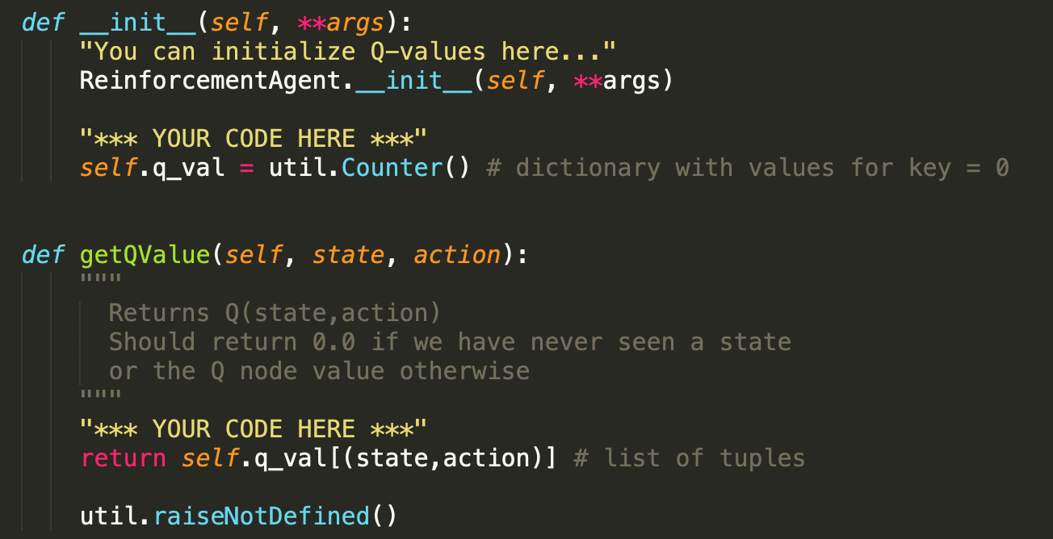

Once all of this was done, I executed the code and got the following error:

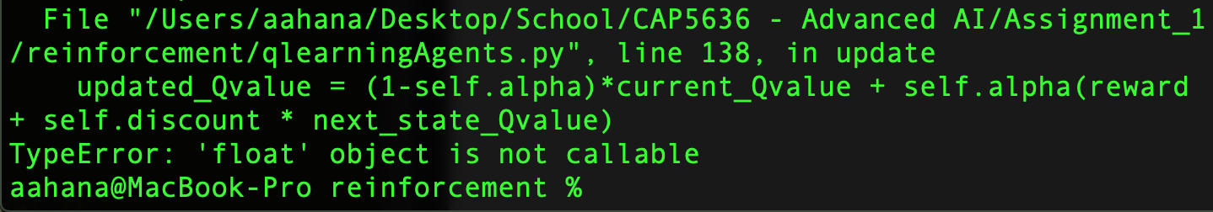

The error was fixed by putting a multiplication symbol after self.alpha in the formula implementation. However, I had another error that I got right after the first iteration.

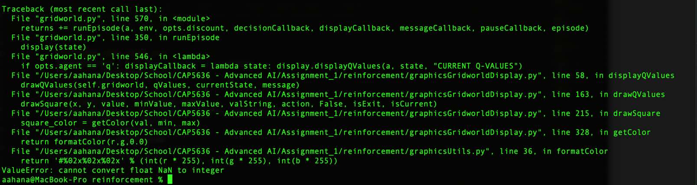

To fix this, I had to check the length of actions inside computeValueFromQValues function. Once, that was fixed, I got the output I was looking for. My output just before exiting the 5th iteration looks as below. Upon exit, the exit state get 0.97.

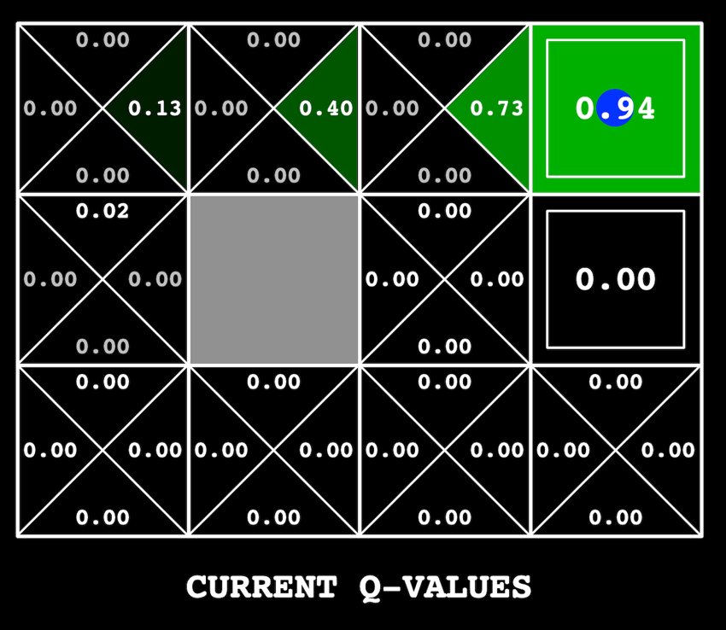

**STEP 2:**

To plot the V-value evolution for the state (0,2), the valueIterationAgents.py was modified to store V-values in a list and plot them. The code snippet is shown below:

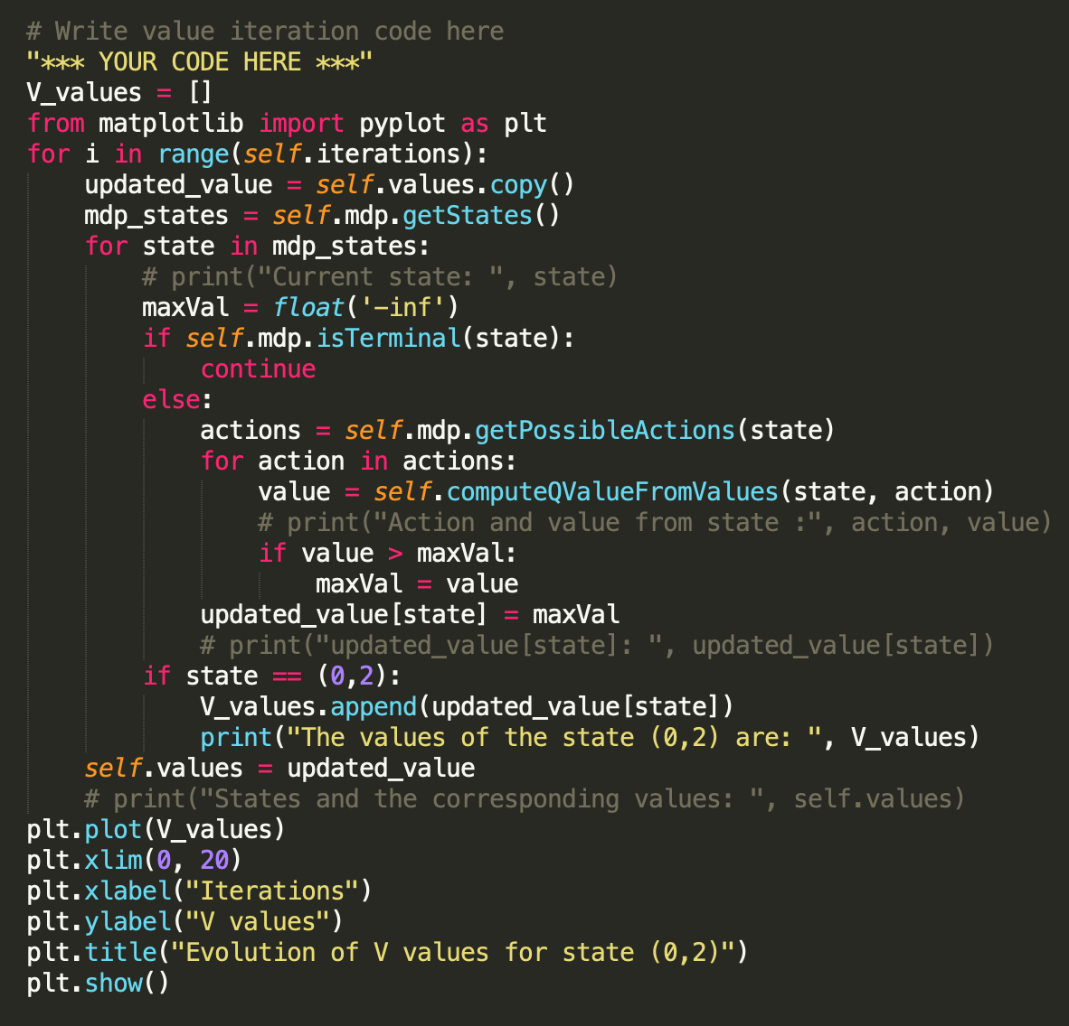

When X-axis is limited to 20, the output looks as follows:

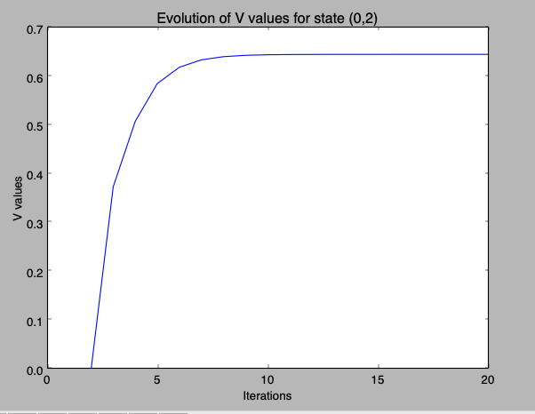

When X-axis goes until 100, the output looks as follows:

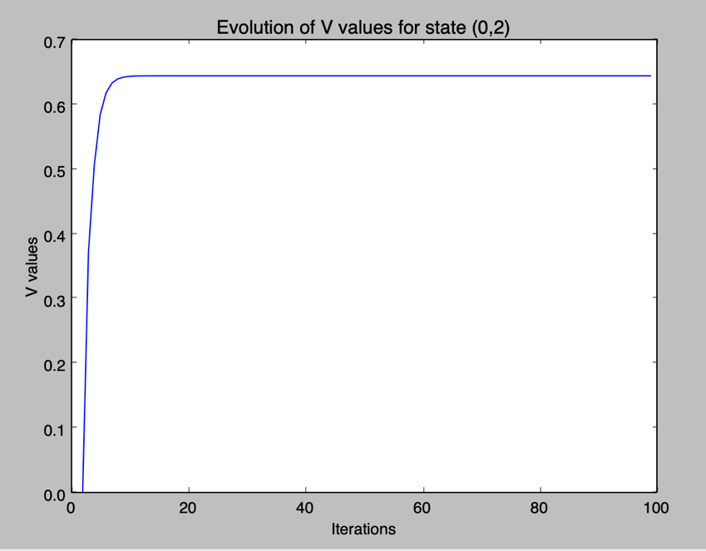

The values after 100 iterations is as follows:

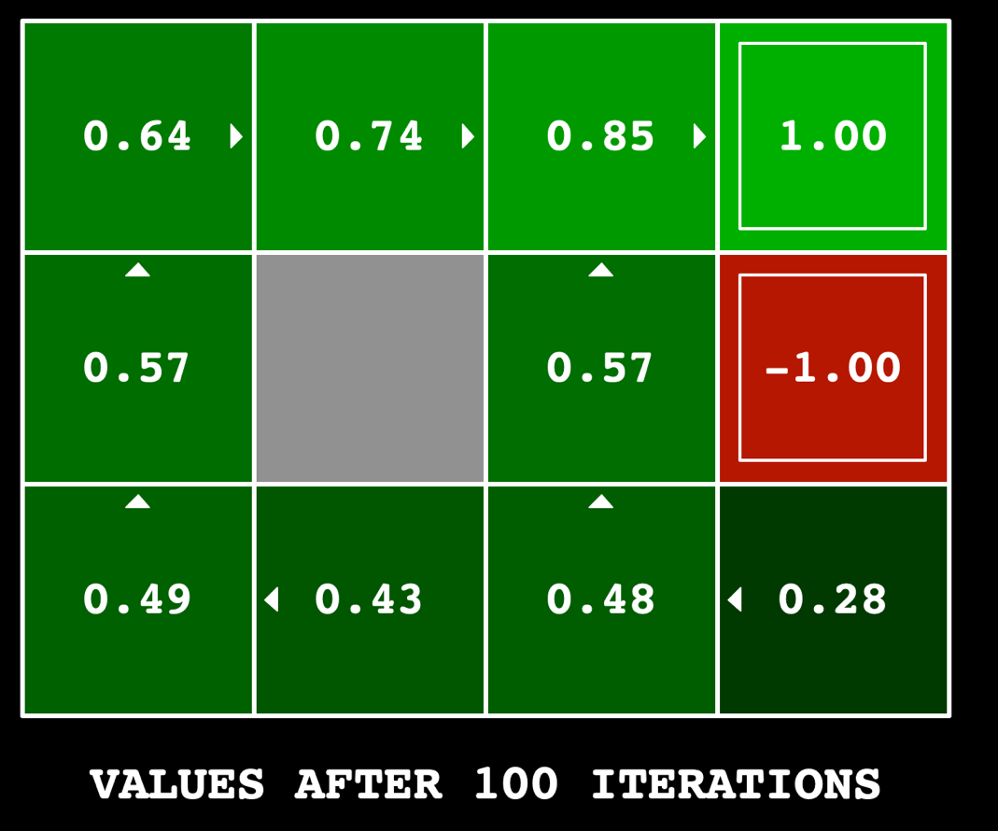

**STEP 3:**

To understand the evolution of Q-values of a state, I modified the update function in the qlearningAgents.py file. The code snippet looks as follows:

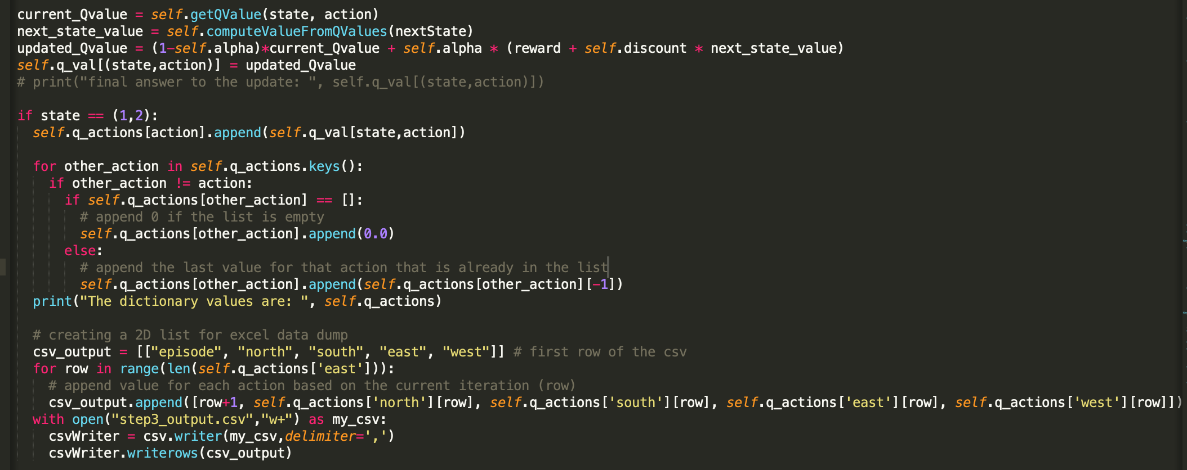

I dump the Q-values for all four actions (North, South, East and West) for the state (1,2) into a csv file. The output with this code after 100 iterations is as follows. However, I noticed that the csv file has 200 values (rows) for each action. This is not right as I should just have 100 values

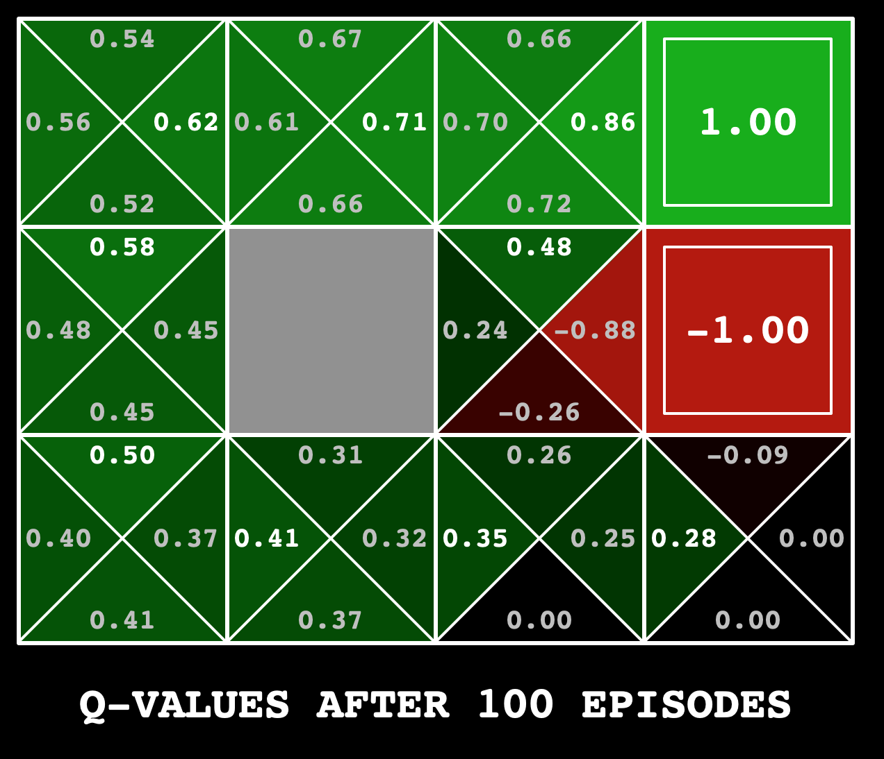

Last few rows of the step3_output.csv file for one the iterations is as follows:

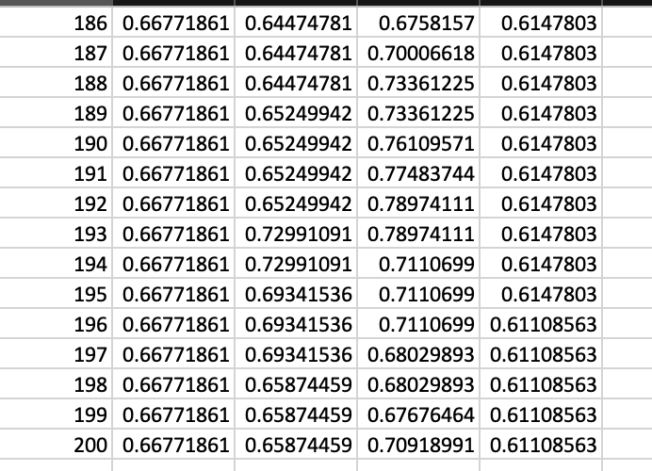

I had to change the entire code and the way I was recording the action values for the state. I decided to save the Q-values only when the agent reached the terminal state. That way, I would get the Q-values for state (1,2) only at the end of each episode. The modified code is below.

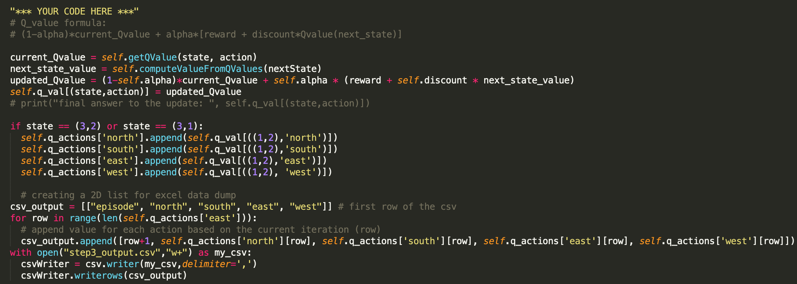

With this, I was able to get Q-values for the state (1,2) at the of each episode. The last few rows of step3_output.csv looks as shown below:

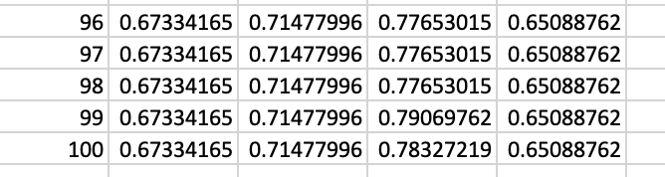

Now that I have the right values in the excel, I was able to plot them. The plot showing Q-values for 100 episodes is shown below:

Below is the plot showing Q-values for 1000 episodes:

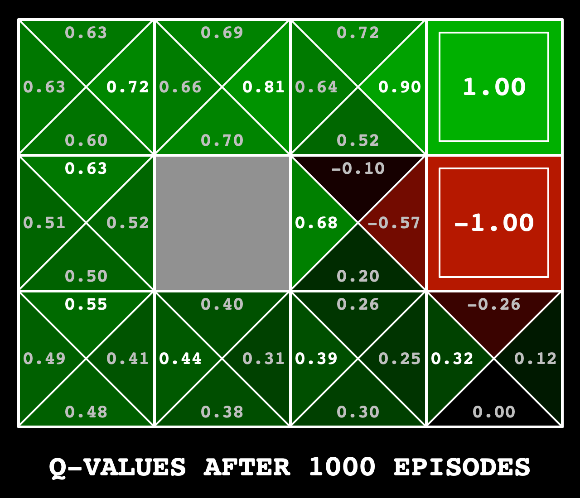

GitHub link: Reinforcement_Learning

<https://github.com/monicabernard/CAP5636_Advanced_AI.git>